- Chapter 8, do programming project 1 on page 178.
Programming project 1: repdigic.c

#include <stdbool.h>
#include <stdio.h>

int main(void) {
bool digit_seen[10] = {false};
bool digit_repeated[10] = {false};
int digit;
long n;

printf("Enter a number: ");
scanf("%ld", &n);

while (n > 0) {
digit = n % 10;
if (digit_seen[digit]) {
digit_repeated[digit] = true;
} else {
digit_seen[digit] = true;
}
n /= 10;
}

bool has_repeats = false;
printf("Repeated digit(s): ");
for (int i = 0; i < 10; i++) {
if (digit_repeated[i]) {
printf("%d ", i);
has_repeats = true;
}
}

if (!has_repeats) {
printf("No repeated digits\n");
} else {
printf("\n");
}

return 0;
}

OUTPUT : 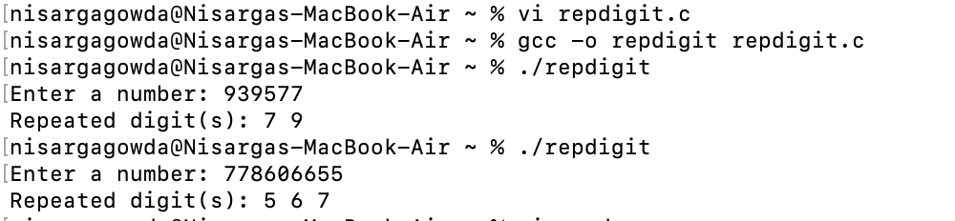

- Chapter 8, do Programming Projects 9 and 16 on page 179, page 180, and page 181.

Programming Projects 9 : random.c

#include <stdio.h>
#include <stdlib.h>
#include <time.h>
#include <stdbool.h>

#define SIZE 10

bool is_valid_move(int x, int y, char grid[SIZE][SIZE]) {
return (x >= 0 && x < SIZE && y >= 0 && y < SIZE && grid[x][y] == '.');
}

void print_grid(char grid[SIZE][SIZE]) {
for (int i = 0; i < SIZE; i++) {
for (int j = 0; j < SIZE; j++) {
printf("%c ", grid[i][j]);
}
printf("\n");
}
}

int main(void) {
char grid[SIZE][SIZE];
int x = SIZE / 2, y = SIZE / 2;
char current_char = 'A';

for (int i = 0; i < SIZE; i++) {
for (int j = 0; j < SIZE; j++) {
grid[i][j] = '.';
}
}

srand((unsigned)time(NULL));
grid[x][y] = current_char++;

while (true) {
int direction = rand() % 4;
int new_x = x;
int new_y = y;

switch (direction) {
case 0: new_x--; break;
case 1: new_x++; break;
case 2: new_y--; break;
case 3: new_y++; break;
}

if (is_valid_move(new_x, new_y, grid)) {
x = new_x;
y = new_y;
grid[x][y] = current_char++;

if (current_char > 'Z') {
break;
}
} else {
int blocked = 0;
for (int i = 0; i < 4; i++) {
int check_x = x;
int check_y = y;
switch (i) {
case 0: check_x--; break;
case 1: check_x++; break;
case 2: check_y--; break;
case 3: check_y++; break;
}
if (!is_valid_move(check_x, check_y, grid)) {
blocked++;
}
}
if (blocked == 4) {
break;
}
}
}

print_grid(grid);
return 0;
}

OUTPUT:
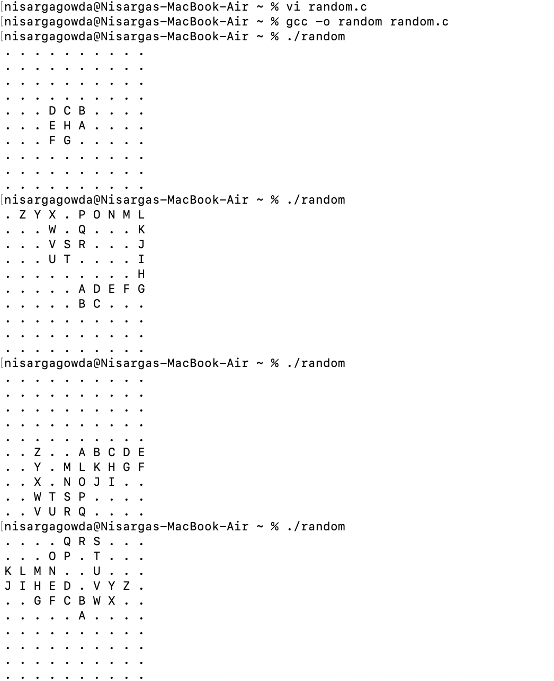

Programming Projects 9: anagram.c

#include <stdio.h>
#include <ctype.h>
#include <string.h>

#define ALPHABET_SIZE 26

void count_letters(const char *word, int counts[ALPHABET_SIZE], int increment) {
while (*word) {
if (isalpha(*word)) {
int index = tolower(*word) - 'a';
counts[index] += increment;
}
word++;
}
}

int main(void) {
char word1[100], word2[100];
int letter_counts[ALPHABET_SIZE] = {0};

printf("Enter first word: ");
fgets(word1, sizeof(word1), stdin);
word1[strcspn(word1, "\n")] = '\0';

count_letters(word1, letter_counts, 1);

printf("Enter second word: ");
fgets(word2, sizeof(word2), stdin);
word2[strcspn(word2, "\n")] = '\0';

count_letters(word2, letter_counts, -1);

for (int i = 0; i < ALPHABET_SIZE; i++) {
if (letter_counts[i] != 0) {
printf("The words are not anagrams.\n");
return 0;
}
}

printf("The words are anagrams.\n");
return 0;
}

OUTPUT:
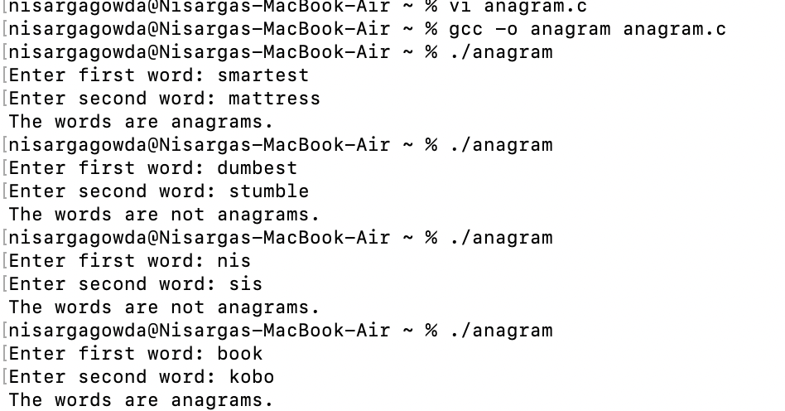

- Chapter 9, do exercise 1 on page 214.

Exercise 1:
The function that is provided contains two errors related to the syntax and declaration of parameters.
1. Parameter Declaration: The parameter `height` is not declared with a type. Both parameters should specify their types.
2. Variable Declaration: The variable `product` should be declared inside the function's body, not after the parameter list.

double triangle_area(double base, double height) {
double product;
product = base * height;
return product / 2;
}

Executed code : triangle.c

#include <stdio.h>

double triangle_area(double base, double height) {
double product;
product = base * height;
return product / 2;
}

int main(void) {
double base, height;

printf("Enter the base of the triangle: ");
scanf("%lf", &base);
printf("Enter the height of the triangle: ");
scanf("%lf", &height);

double area = triangle_area(base, height);
printf("The area of the triangle is: %.2f\n", area);

return 0;
}

OUTPUT:
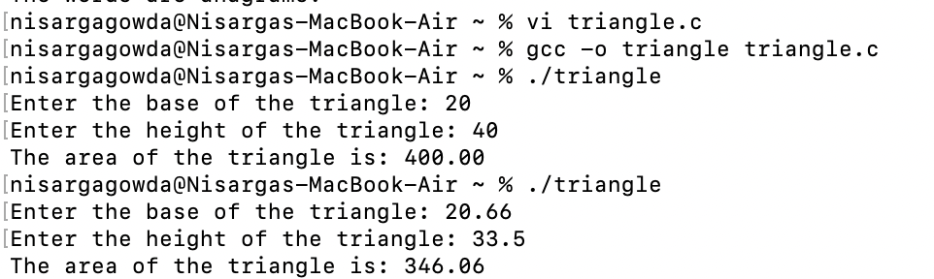

- Chapter 9, do Programming Project 4 on page 217.

Programming Project 4:

#include <stdio.h>
#include <ctype.h>
#include <string.h>
#include <stdbool.h>

#define ALPHABET_SIZE 26

void read_word(int counts[ALPHABET_SIZE]) {
char word[100];
printf("Enter a word: ");
fgets(word, sizeof(word), stdin);
word[strcspn(word, "\n")] = '\0';

for (int i = 0; word[i] != '\0'; i++) {
if (isalpha(word[i])) {
int index = tolower(word[i]) - 'a';
counts[index]++;
}
}
}

bool equal_array(int counts1[ALPHABET_SIZE], int counts2[ALPHABET_SIZE]) {
for (int i = 0; i < ALPHABET_SIZE; i++) {
if (counts1[i] != counts2[i]) {
return false;
}
}
return true;
}

int main(void) {
int letter_counts1[ALPHABET_SIZE] = {0};
int letter_counts2[ALPHABET_SIZE] = {0};

read_word(letter_counts1);
read_word(letter_counts2);

if (equal_array(letter_counts1, letter_counts2)) {
printf("true\n");
} else {
printf("false\n");
}

return 0;
}

OUTPUT:
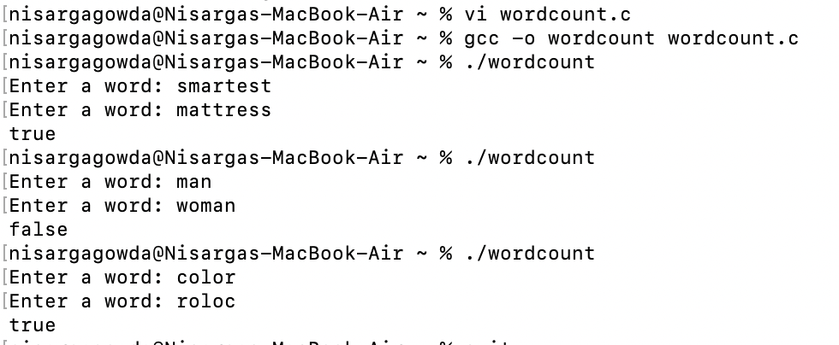

Write a program that generates a "random walk" across a 10 x 10 array. The array will con- tain characters (all ' . ' initially). The program must randomly "walk" from element to ele- ment, always going up, down, left, or right by one element. The elements visited by the program will be labeled with the letters A through Z, in the order visited. Here's an example of the desired output: A . . . . . . . . . B C D . . . . . . . • F E . . . . . . . H G . . . . . . . . I . . . . . . . . . J . . . . . . . Z . K . . R S T U V Y . L M P Q . . . W X . . N O . . . . . . . . . . . . . . . . . Hint: Use the srand and rand functions (see deal. c) to generate random numbers. After generating a number, look at its remainder when divided by 4. There are four possible values for the remainder-0, 1, 2, and 3-indicating the direction of the next move. Before performing a move, check that (a) it won't go outside the array, and (b) it doesn't take us to an element that already has a letter assigned. If either condition is violated, try moving in another direction. If all four directions are blocked, the program must terminate. Here's an example of premature termination: A B G H I . . . . . . C F . J K . . . . .D E . M L . . . . . . . . N O . . . . . . W X Y P Q . . . . . V U T S R . . . . . . . . . . . . . . . . . . . . . . . . . . . . . . . . . . . . . . . . . . . Y is blocked on all four sides, so there's no place to put Z. Deal.c /* Deals a random hand of cards */ #include < stdbool.h› #include ‹stdio.h> #include ‹stdlib.h> #include <time.h> /* C99 only * / #define NUM_SUITS 4 #define NUM_RANKS 13 int main (void){ bool in_hand [NUM_SUITS] [NUM_RANKS] = {false} ; int num_cards, rank, suit; const char rank_code[] = {'2', '3', '4', '5','6','7','8','9','t','j','q','k','a'}; const char suit_codel] = {'c', 'a', 'h', 's'}; srand ( (unsigned) time (NULL)) ; printf ("Enter number of cards in hand: "); scanf ("&d", &num_ cards) ; printf ("Your hand:") ; while (num_cards > 0) { suit = rand () % NUM_SUITS; rank = rand () % NUM_RANKS ; /* picks a random suit */ /* picks a random rank */ if (!in_hand [suit] [rank]) { in_hand [suit] [rank] = true; num cards--; printf (" %c%c", rank_code [rank], suit _code [suit]) ; } } printf ("\n") ; return 0; }

Modify the repdigit. c program of Section 8.1 so that it shows which digits (if any) were repeated: Enter a number: 939577(underlined) Repeated digit (s): 7 9 repdigit.c /* Checks numbers for repeated digits */ #include <stdbool.h> #include <stdio.h> int main (void) { bool digit_seen [10] = {false}; int digit; long n; printf ("Enter a number: ") ; scanf ("%ld", &n) ; while (n > 0) { digit = n % 10; if (digit_ seen[digit]) break; digit_seen [digit] = true; n /= 10; ｝ if (n > 0) printf ("Repeated digit\n"); else printf ("No repeated digit\n") ; return 0; }

Write a program that tests whether two words are anagrams (permutations of the same let- ters): Enter first word: smartest Enter second word: mattress The words are anagrams. Enter first word: dumbest Enter second word: stumble The words are not anagrams. Write a loop that reads the first word, character by character, using an array of 26 integers to keep track of how many times each letter has been seen. (For example, after the word smart- est has been read, the array should contain the values 1 0 0 0 1 0 0 0 0 0 0 0 1 0 0 0 0 1 2 2 0 0 0 0 0 0, reflecting the fact that smartest contains one a, one e, one m, one r, two s's and two t's.) Use another loop to read the second word, except this time decrementing the corresponding array element as each letter is read. Both loops should ignore any characters that aren't letters, and both should treat upper-case letters in the same way as lower-case letters. After the second word has been read, use a third loop to check whether all the elements in the array are zero. If so, the words are anagrams. Hint: You may wish to use functions from <ctype. h>, such as isalpha and tolower.
Modify Programming Project 16 from Chapter 8 so that it includes the following functions: void read_word (int counts [26]) ; bool equal_array (int counts1[26], int counts2 [26]) ; main will call read _word twice, once for each of the two words entered by the user. As it reads a word, read word will use the letters in the word to update the counts array, as described in the original project. (main will declare two arrays, one for each word. These arrays are used to track how many times each letter occurs in the words.) main will then call equal _array, passing it the two arrays. equal_ array will return true if the ele- ments in the two arrays are identical (indicating that the words are anagrams) and false otherwise. Programming project 16: #include <stdio.h> #include <ctype.h> #include <string.h> #define ALPHABET_SIZE 26 void count_letters(const char *word, int counts[ALPHABET_SIZE], int increment) { while (*word) { if (isalpha(*word)) { int index = tolower(*word) - 'a'; counts[index] += increment; // Increment or decrement based on the input } word++; } } int main(void) { char word1[100], word2[100]; int letter_counts[ALPHABET_SIZE] = {0}; // Input the first word printf("Enter first word: "); fgets(word1, sizeof(word1), stdin); word1[strcspn(word1, "\n")] = '\0'; // Remove newline character // Count letters in the first word (increment) count_letters(word1, letter_counts, 1); // Input the second word printf("Enter second word: "); fgets(word2, sizeof(word2), stdin); word2[strcspn(word2, "\n")] = '\0'; // Remove newline character // Count letters in the second word (decrement) count_letters(word2, letter_counts, -1); // Check if all counts are zero for (int i = 0; i < ALPHABET_SIZE; i++) { if (letter_counts[i] != 0) { printf("The words are not anagrams.\n"); return 0; } } printf("The words are anagrams.\n"); return 0; }

